Sacred Self-Mastery program
with Julia Mikk
8th Module: Your Life Purpose

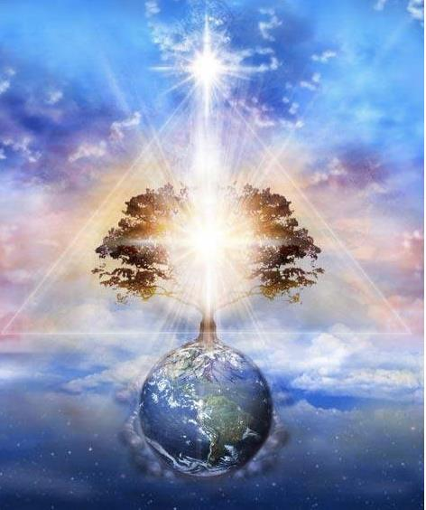

After listening to the audio lecture, what does your life purpose mean to you now?
………………………………………………………………………………………………………………………………………………………………….
………………………………………………………………………………………………………………………………………………………………….………………………………………………………………………………………………………………………………………………………………….
………………………………………………………………………………………………………………………………………………………………….
………………………………………………………………………………………………………………………………………………………………….
………………………………………………………………………………………………………………………………………………………………….………………………………………………………………………………………………………………………………………………………………….
………………………………………………………………………………………………………………………………………………………………….………………………………………………………………………………………………………………………………………………………………….
………………………………………………………………………………………………………………………………………………………………….………………………………………………………………………………………………………………………………………………………………….
………………………………………………………………………………………………………………………………………………………………….
………………………………………………………………………………………………………………………………………………………………….
………………………………………………………………………………………………………………………………………………………………….………………………………………………………………………………………………………………………………………………………………….
………………………………………………………………………………………………………………………………………………………………….

What do you feel is your life purpose at this moment? What comes naturally and easily to you when you think of it? This is the key: naturally and easily.
………………………………………………………………………………………………………………………………………………………………….
………………………………………………………………………………………………………………………………………………………………….………………………………………………………………………………………………………………………………………………………………….
………………………………………………………………………………………………………………………………………………………………….
………………………………………………………………………………………………………………………………………………………………….
………………………………………………………………………………………………………………………………………………………………….………………………………………………………………………………………………………………………………………………………………….
………………………………………………………………………………………………………………………………………………………………….………………………………………………………………………………………………………………………………………………………………….
………………………………………………………………………………………………………………………………………………………………….
………………………………………………………………………………………………………………………………………………………………….………………………………………………………………………………………………………………………………………………………………….
………………………………………………………………………………………………………………………………………………………………….………………………………………………………………………………………………………………………………………………………………….………………………………………………………………………………………………………………………………………………………………….
………………………………………………………………………………………………………………………………………………………………….

What is the feeling or emotion through which your life purpose expresses itself? How do you know when it is the Infinite Intelligence of Spirit asking you to step forward?
………………………………………………………………………………………………………………………………………………………………….
………………………………………………………………………………………………………………………………………………………………….………………………………………………………………………………………………………………………………………………………………….
………………………………………………………………………………………………………………………………………………………………….………………………………………………………………………………………………………………………………………………………………….
………………………………………………………………………………………………………………………………………………………………….
………………………………………………………………………………………………………………………………………………………………….………………………………………………………………………………………………………………………………………………………………….
………………………………………………………………………………………………………………………………………………………………….
………………………………………………………………………………………………………………………………………………………………….
………………………………………………………………………………………………………………………………………………………………….
………………………………………………………………………………………………………………………………………………………………….
………………………………………………………………………………………………………………………………………………………………….
………………………………………………………………………………………………………………………………………………………………….
What are the three most obvious steps you are Called to take in your life right now:
1)……………………………………………………………………………………………………………………………………………….……………… ………………………………………………………………………………………………………………………………………………………………….
………………………………………………………………………………………………………………………………………………………………….
………………………………………………………………………………………………………………………………………………………………….
………………………………………………………………………………………………………………………………………………………………….2)……………………………………………………………………………………………………………………………………………….……………… ………………………………………………………………………………………………………………………………………………………………….
………………………………………………………………………………………………………………………………………………………………….
………………………………………………………………………………………………………………………………………………………………….
………………………………………………………………………………………………………………………………………………………………….3)……………………………………………………………………………………………………………………………………………….………………………………………………………………………………………………………………………………………………………………………………….
………………………………………………………………………………………………………………………………………………………………….
………………………………………………………………………………………………………………………………………………………………….
………………………………………………………………………………………………………………………………………………………………….
………………………………………………………………………………………………………………………………………………………………….
………………………………………………………………………………………………………………………………………………………………….

How committed are you to taking these steps? What can increase the depth of your devotion to trusting this divine guidance within you?
………………………………………………………………………………………………………………………………………………………………….
………………………………………………………………………………………………………………………………………………………………….
………………………………………………………………………………………………………………………………………………………………….………………………………………………………………………………………………………………………………………………………………….
………………………………………………………………………………………………………………………………………………………………….………………………………………………………………………………………………………………………………………………………………….
………………………………………………………………………………………………………………………………………………………………….
………………………………………………………………………………………………………………………………………………………………….
………………………………………………………………………………………………………………………………………………………………….………………………………………………………………………………………………………………………………………………………………….
………………………………………………………………………………………………………………………………………………………………….………………………………………………………………………………………………………………………………………………………………….
………………………………………………………………………………………………………………………………………………………………….
………………………………………………………………………………………………………………………………………………………………….
………………………………………………………………………………………………………………………………………………………………….………………………………………………………………………………………………………………………………………………………………….
………………………………………………………………………………………………………………………………………………………………….………………………………………………………………………………………………………………………………………………………………….

