Sacred Self-Mastery program
with Julia Mikk
2nd Module: Find Peace Within And Without

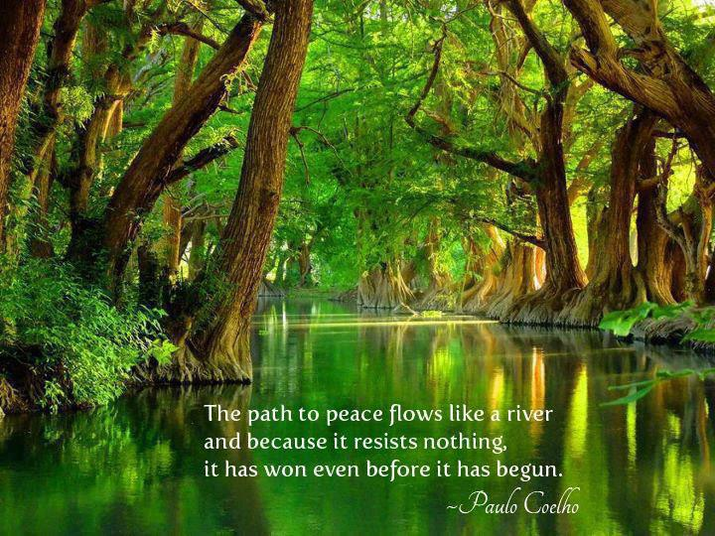

Listen to the audio lecture, and write down the most important insights you receive from it. Even if the information is familiar to you, what were the deeper clarifications or new inspirations that awakened inside of you after you listened to the talk?
………………………………………………………………………………………………………………………………………………………………….
………………………………………………………………………………………………………………………………………………………………….………………………………………………………………………………………………………………………………………………………………….
………………………………………………………………………………………………………………………………………………………………….………………………………………………………………………………………………………………………………………………………………….
………………………………………………………………………………………………………………………………………………………………….………………………………………………………………………………………………………………………………………………………………….
………………………………………………………………………………………………………………………………………………………………….………………………………………………………………………………………………………………………………………………………………….
………………………………………………………………………………………………………………………………………………………………….………………………………………………………………………………………………………………………………………………………………….
………………………………………………………………………………………………………………………………………………………………….
………………………………………………………………………………………………………………………………………………………………….
………………………………………………………………………………………………………………………………………………………………….………………………………………………………………………………………………………………………………………………………………….
………………………………………………………………………………………………………………………………………………………………….
Notice how your daily behavior at work or relationships start changing after your daily meditations. What are you thinking, feeling or saying in a new way? Notice the small changes. They will keep growing, especially when noticed and appreciated.
It’s like a garden. You really want to pay attention to those delicate little sprouts when they begin to come out of the soil. Make notes about what you notice here:
………………………………………………………………………………………………………………………………………………………………….
………………………………………………………………………………………………………………………………………………………………….………………………………………………………………………………………………………………………………………………………………….
………………………………………………………………………………………………………………………………………………………………….………………………………………………………………………………………………………………………………………………………………….
………………………………………………………………………………………………………………………………………………………………….………………………………………………………………………………………………………………………………………………………………….
………………………………………………………………………………………………………………………………………………………………….………………………………………………………………………………………………………………………………………………………………….
………………………………………………………………………………………………………………………………………………………………….………………………………………………………………………………………………………………………………………………………………….
………………………………………………………………………………………………………………………………………………………………….
………………………………………………………………………………………………………………………………………………………………….
………………………………………………………………………………………………………………………………………………………………….
CURIOUS WONDER
The changes you are noticing do not have to be all positive and comfortable. The mind has its old ideas about what is positive. It can quickly judge when something does not seem familiar. Just know that the energy of goodwill you are activating through your daily meditations will bring positive changes into your life. Even if some new situations seem uncomfortable on the surface at first, at the core they are important gifts, offering a valuable transformation. So, notice what is new, and acknowledge it, even if you at first don’t fully understand the gift of it.
………………………………………………………………………………………………………………………………………………………………….
………………………………………………………………………………………………………………………………………………………………….………………………………………………………………………………………………………………………………………………………………….
………………………………………………………………………………………………………………………………………………………………….………………………………………………………………………………………………………………………………………………………………….
………………………………………………………………………………………………………………………………………………………………….………………………………………………………………………………………………………………………………………………………………….
………………………………………………………………………………………………………………………………………………………………….………………………………………………………………………………………………………………………………………………………………….
………………………………………………………………………………………………………………………………………………………………….………………………………………………………………………………………………………………………………………………………………….
………………………………………………………………………………………………………………………………………………………………….
………………………………………………………………………………………………………………………………………………………………….
………………………………………………………………………………………………………………………………………………………………….
A CURIOUS NOTICING WITHOUT JUDGMENT
What would it feel like to notice something challenging with curiosity and without judgment?
………………………………………………………………………………………………………………………………………………………………….
………………………………………………………………………………………………………………………………………………………………….………………………………………………………………………………………………………………………………………………………………….
………………………………………………………………………………………………………………………………………………………………….………………………………………………………………………………………………………………………………………………………………….
………………………………………………………………………………………………………………………………………………………………….………………………………………………………………………………………………………………………………………………………………….
………………………………………………………………………………………………………………………………………………………………….………………………………………………………………………………………………………………………………………………………………….
………………………………………………………………………………………………………………………………………………………………….………………………………………………………………………………………………………………………………………………………………….
………………………………………………………………………………………………………………………………………………………………….
………………………………………………………………………………………………………………………………………………………………….
………………………………………………………………………………………………………………………………………………………………….………………………………………………………………………………………………………………………………………………………………….
………………………………………………………………………………………………………………………………………………………………….
Are you noticing a sense of openness with this feeling of ‘curiosity without judgment’? If so, where in your body do you notice most of this openness, and what does it feel like? What’s its texture, color, depth, shape (maybe even a taste). Describe it here:
………………………………………………………………………………………………………………………………………………………………….
………………………………………………………………………………………………………………………………………………………………….………………………………………………………………………………………………………………………………………………………………….
………………………………………………………………………………………………………………………………………………………………….………………………………………………………………………………………………………………………………………………………………….
………………………………………………………………………………………………………………………………………………………………….………………………………………………………………………………………………………………………………………………………………….
………………………………………………………………………………………………………………………………………………………………….………………………………………………………………………………………………………………………………………………………………….
………………………………………………………………………………………………………………………………………………………………….………………………………………………………………………………………………………………………………………………………………….
………………………………………………………………………………………………………………………………………………………………….
………………………………………………………………………………………………………………………………………………………………….
………………………………………………………………………………………………………………………………………………………………….
Do you communicate differently when you are settled in this place of ‘curiosity without judgment’? How does it affect your actions? How does your body feel when you are in it? How is it different from that old tendency to quickly judge something (or someone) and immediately contract around it?
………………………………………………………………………………………………………………………………………………………………….
………………………………………………………………………………………………………………………………………………………………….………………………………………………………………………………………………………………………………………………………………….
………………………………………………………………………………………………………………………………………………………………….………………………………………………………………………………………………………………………………………………………………….
………………………………………………………………………………………………………………………………………………………………….………………………………………………………………………………………………………………………………………………………………….
………………………………………………………………………………………………………………………………………………………………….………………………………………………………………………………………………………………………………………………………………….
………………………………………………………………………………………………………………………………………………………………….………………………………………………………………………………………………………………………………………………………………….
………………………………………………………………………………………………………………………………………………………………….
………………………………………………………………………………………………………………………………………………………………….
………………………………………………………………………………………………………………………………………………………………….………………………………………………………………………………………………………………………………………………………………….
………………………………………………………………………………………………………………………………………………………………….………………………………………………………………………………………………………………………………………………………………….
………………………………………………………………………………………………………………………………………………………………….………………………………………………………………………………………………………………………………………………………………….
………………………………………………………………………………………………………………………………………………………………….

